21M.383: Computational Music Theory and Analysis
QUIZ 1
2023

Please write your name on this page and not on any other page.

You have 40 minutes to finish the exam. If you finish the exam early, please feel free to hand it in and take a break until the time announced in class.

Good luck! And Congrats on all the hard work so far this term. I am confident everyone can do well.

Name _______________________________________________

Used Course Grade
Objective Qs Question 1 Question 2 Total Notes Grade to this point
__________ ________ ___________ _________ ____ ______ ___________
- pts) (40 pts) (40 pts) (100)

- Objective / Reading Comprehension: (20pts total)
(a few words or one sentence or less for each of these)

- From the reading where Sophia Sun was an author, name one example of a sentiment/music relationship that the authors identified as significant: (4 pts)

- Considering MIDI vs MusicXML, what is one thing that MIDI encodes more accurately and one thing MusicXML encodes more accurately? (5pts)

- What did the publication jointly authored by Bret Aarden and David Huron contribute to the understanding of a larger context for computational music understanding (4pts)

- Which music21 iterating method is closest to a Depth First Search and why? (4 pts)

- Who wrote “there is no such thing as a good or bad representation of music per se” and in what article? (3 pts)

Optional (Bonus 1pt) from an extra credit reading: What did Donald Byrd do that appeared in this class?
2. Open Answers (2 questions, 40 points each)

Choose TWO of the following THREE questions and answer them in approximately 100–200 words each (half a page to a page depending on handwriting size). If all three are answered, only the first two will be graded. Continue on the back if needed.
Make reference to at least one specific AUTHOR (or thinker) in your work.
Musical staves are provided at the bottom of each page in case you would like to use them.

- Explain what the “Global Rule” for species counterpoint is, what motivated it, and it’s described, and how it connects with computation. [Please use the staves for this]
- Explain what the difference between “equality/same” and “equivalence” is in a musical context, including situations/conceptual constructs in which some equivalences may be more or less relevant.
- Consider the article in which this famous diagram appeared:
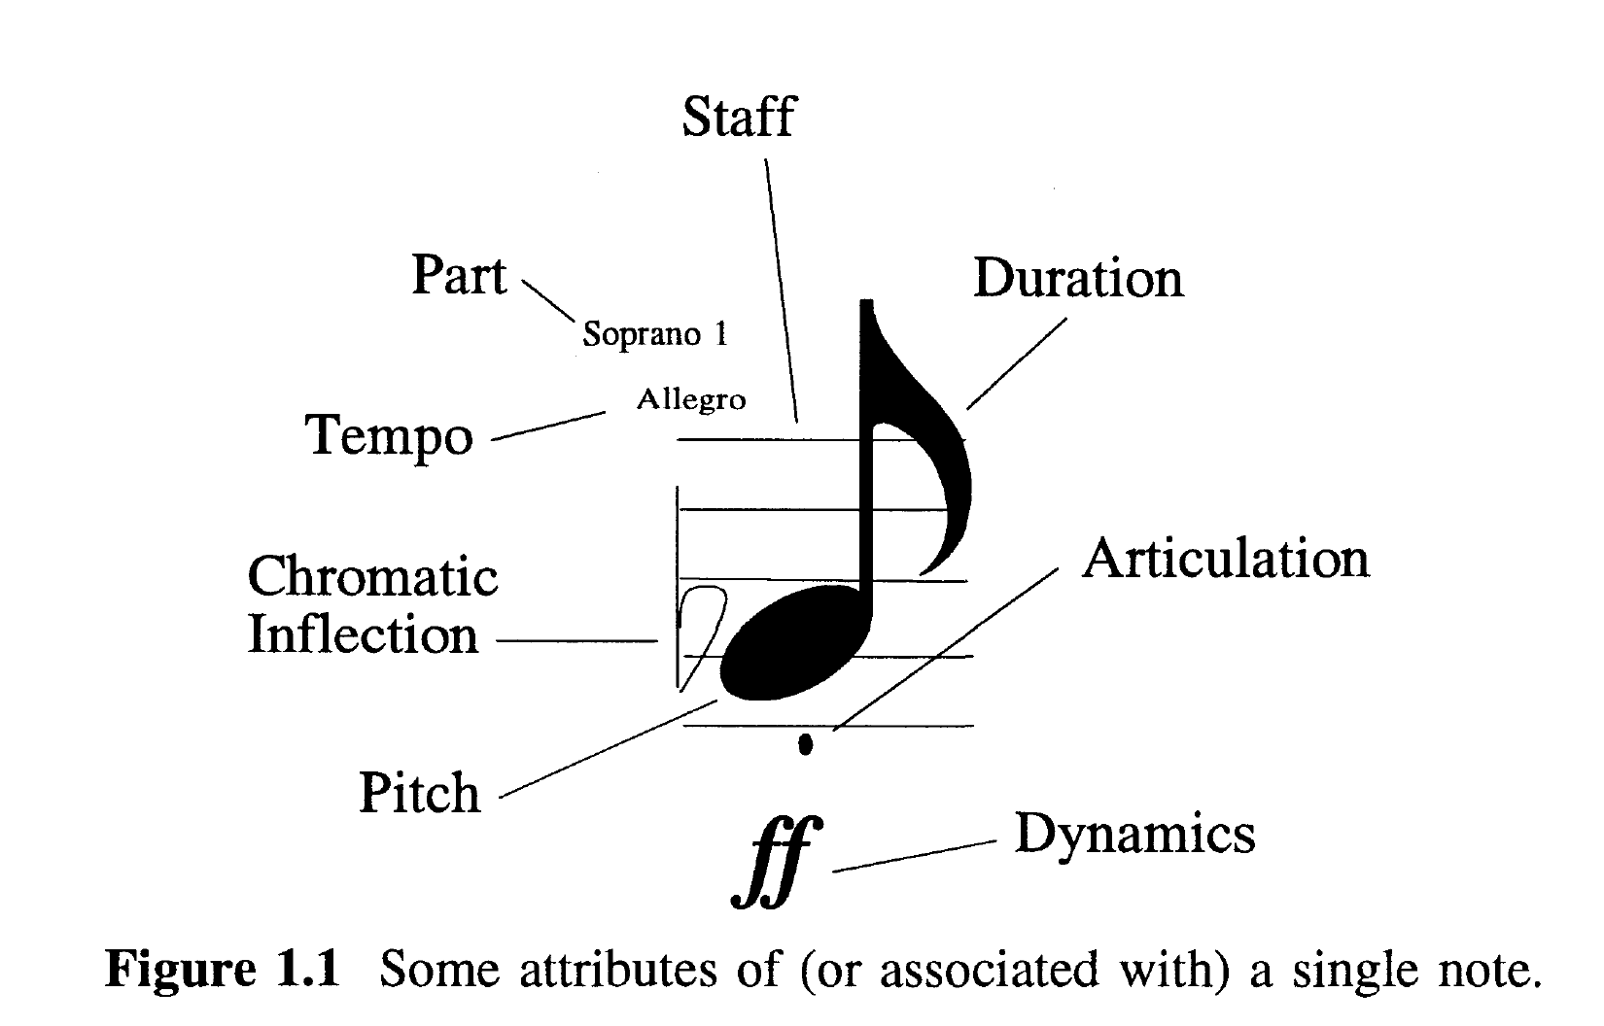
Image courtesy of Esfield on CCARH. License: CC BY-NC-SA.
Name the author and article and discuss the author’s “Three Contexts” that describe musical information (The author actually mentioned five, though the article focused on three; any of the five are acceptable)

Answers will be graded out of 40. 15 pts = C, 20 = B, 25 = B+, 30 = A–, 35 = A.

Answer to Question [ A B C ] (please circle one)



Answer to Question [ A B C ] (please circle one)




MIT OpenCourseWare
https://ocw.mit.edu/

21M.383 Computational Music Theory and Analysis
Spring 2023

For information about citing these materials or our Terms of Use, visit: https://ocw.mit.edu/terms.

